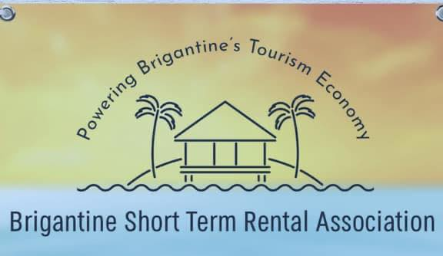

PRESS RELEASE

SHORT TERM RENTAL PROPERTY OWNERS ORGANIZE TO OPPOSE BRIGANTINE PROPOSED HARSH NEW RULES

Approximately 500 Brigantine property owners have incorporated Brigantine Short Term Rental Association Inc., a New Jersey nonprofit corporation (“Association”) to promote family-based tourism in Brigantine, pursue harmony between its members and other island residents, and collaborate with Brigantine City officials on productive solutions to challenges created by tourism in the City. The Association is opposing Brigantine’s new short term rental proposal because the regulations:

- are overly restrictive;
- will stifle the economic vitality, tourism, and vibrancy of the City;
- are being considered without any economic analysis of their impact;
- were prepared based upon inaccurate information;
- are being collected to fund undocumented expenses of the City;
- are inconsistent with the City’s Master Plan; and
- are legally defective.

The proposal includes 18 recommendations. One recommendation mandates a thirty day minimum night stay for all rentals during the winter season of November through March in order to “give the residents a break” according to Mayor Sera. “If imposed, the thirty day minimum night stay will destroy all tourism during the off-season. We currently see weekend tourism in off-season for events, conferences, golfing, fishing and children’s sports tournaments. Our local businesses, restaurants, shops and churches will suffer if this requirement is imposed. Short term rentals are already down by 30% due to an increase in flight and international travel.” Cathy Adams Broker/Salesperson Weichert Brigantine.

Another recommendation requires all properties with 3 or more bedrooms to install noise monitoring devices, a recommendation to the City by a local builder. Based upon the information obtained by the Association, it appears that the noise complaints relate to 4 properties on one street. The City already has a noise ordinance which is not being enforced by the City police as admitted by the City’s Short Term Rental Committee.

The City has proposed a $250 per bedroom license fee which is a 900% increase for a 6 bedroom summer rental house. Pursuant to the Association’s Open Public Records Request, the City cannot confirm an accurate number of short term rental licensed bedrooms. Based upon available data, the Association has calculated that there are at least 2,747 licensed bedrooms resulting in proposed revenues of $686,750, an increase in fees by $506,885. The City has not provided any demonstrative need for this excessive increase. Mayor Sera has confirmed that the money will be placed into the City’s general fund. “This looks like a solution looking for a problem.” Michael Malter, short term rental owner and member of the Association.

The City is proposing a 1% municipal occupancy tax on bookings in addition to the 11.625% tax already imposed. “This additional tax will put us at a competitive disadvantage. No other barrier island has such a high rate on short term rentals. Other shore towns, such as Atlantic City and the Wildwoods, which impose a municipal tax, have a reduced state occupancy tax.” Larry Kosta, Trustee of the Association.

“The City is considering imposing severe restrictions in an arbitrary and capricious manner without any demonstrative need or economic analysis of the consequences. The City currently has all the legal tools at its disposal to address the few isolated problems without over-reacting and devastating its thriving tourism economy. Many of the proposed regulations are legally unenforceable, unconstitutional and inconsistent with the City’s own Master Plan” says Dorothy Bolinsky, a New Jersey attorney and Trustee of the Association.

“There is a great misconception that the short term rental properties are owned by large companies and absentee landlords. That is not the case, these properties are owed by individuals who take great pride in our properties. We are ambassadors of the community. Many of the owners only rent their properties a few weeks a year. If passed these requirements will have a substantial impact on many of us, affect property values and will force some people to sell their properties.” Chrissy Keffer, member of the Association and owner of short term rental properties in Brigantine.

The Association is asking the City Council to reject the proposal of the City’s Short Term Rental Subcommittee, in order to further investigate collaborative and productive solutions to improve the harmony among all property owners, properly evaluate the economic impact of the short term rentals on the local economy before adopting any new regulations and in the meantime enforce the current ordinances. The Association’s position has been endorsed by the New Jersey Shore Rentals Coalition.

A full copy of the proposal is available on the City of Brigantine website.

# # #

Contacts:
Dorothy Bolinsky – Phone: 609.870.0533
Email: Dorothy.bolinsky@faegredrinker.com

